**LAB PROGRAM 0:**

Write a C or C++ program to pass matrices as parameters in all programs to perform:

1. Matrix Addition and Subtraction
2. Matrix Multiplication
3. Sum of principal diagonals and non principal diagonals
4. Find sum of rows and columns
5. Print transpose of matrix
6. Check if given matrix is symmetric or not

**OBSERVATION:**

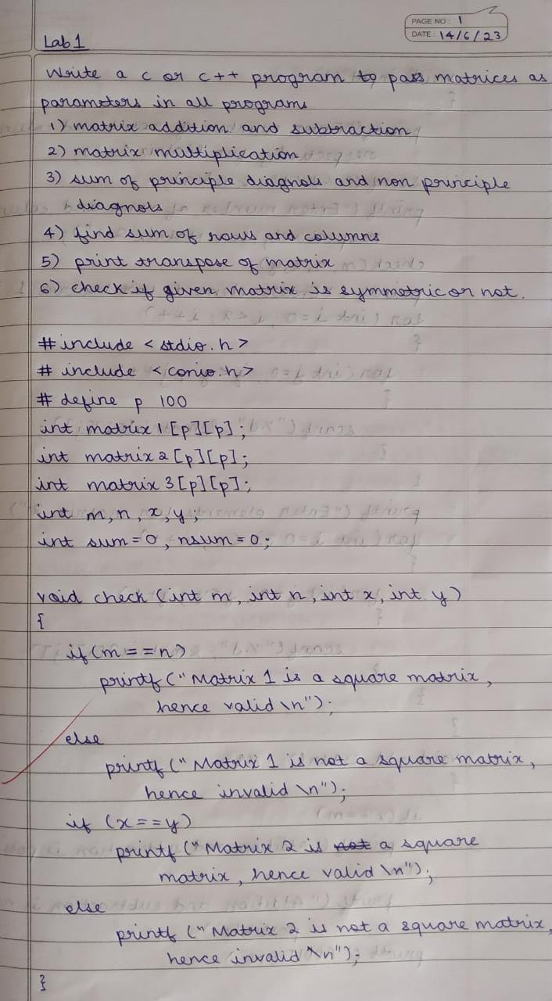

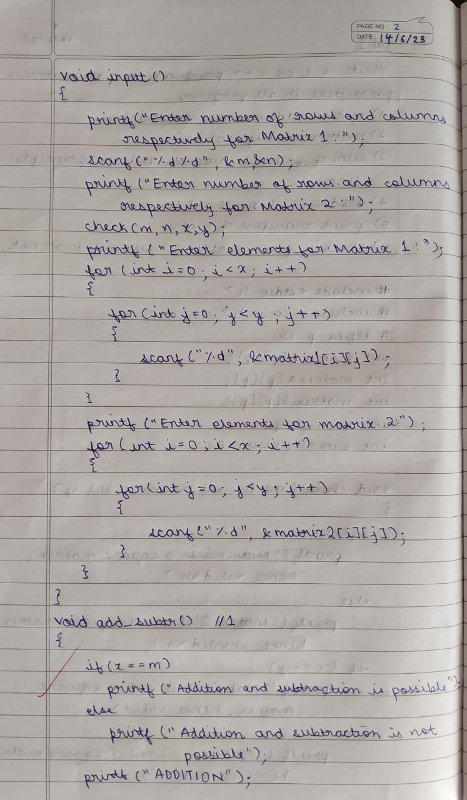

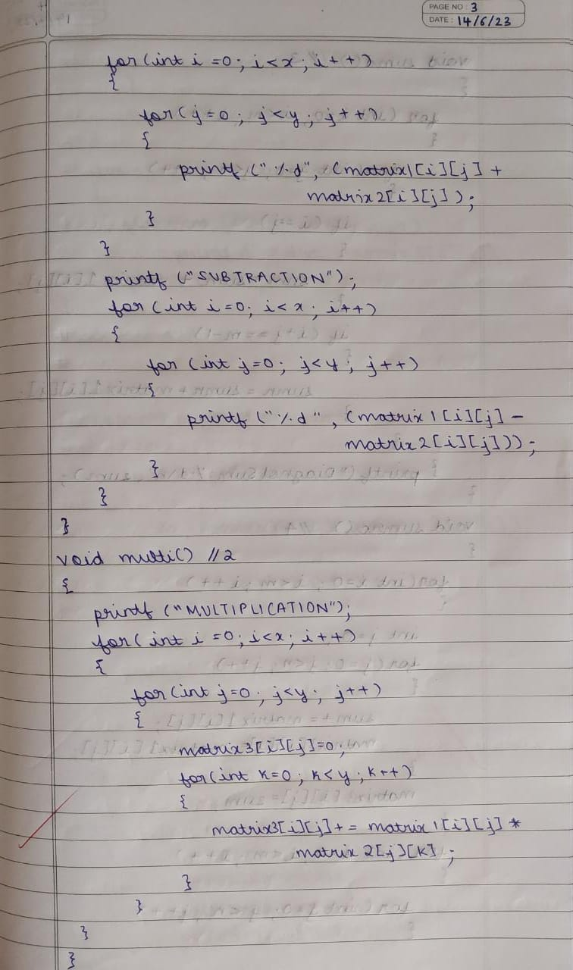

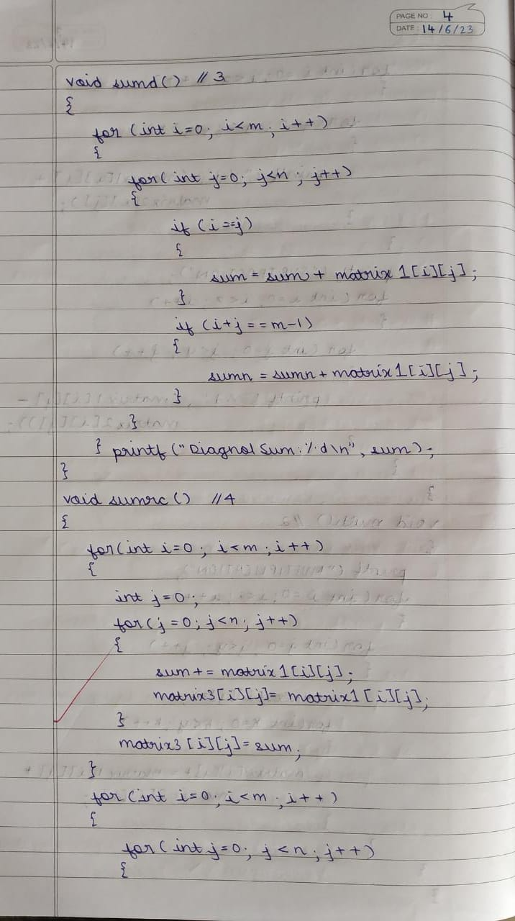

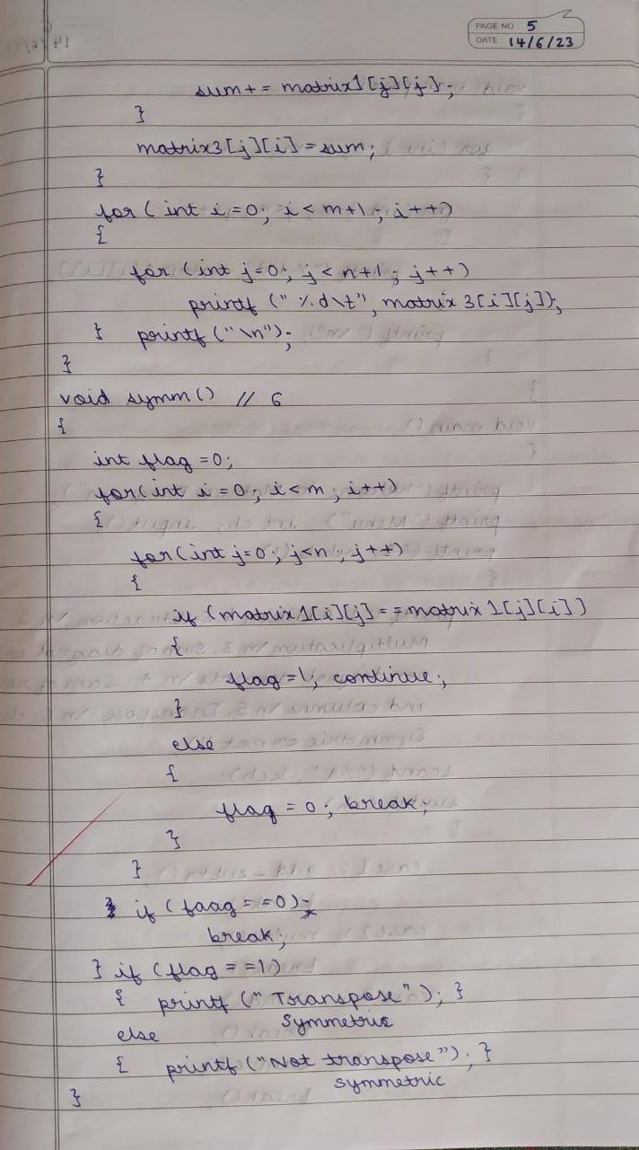

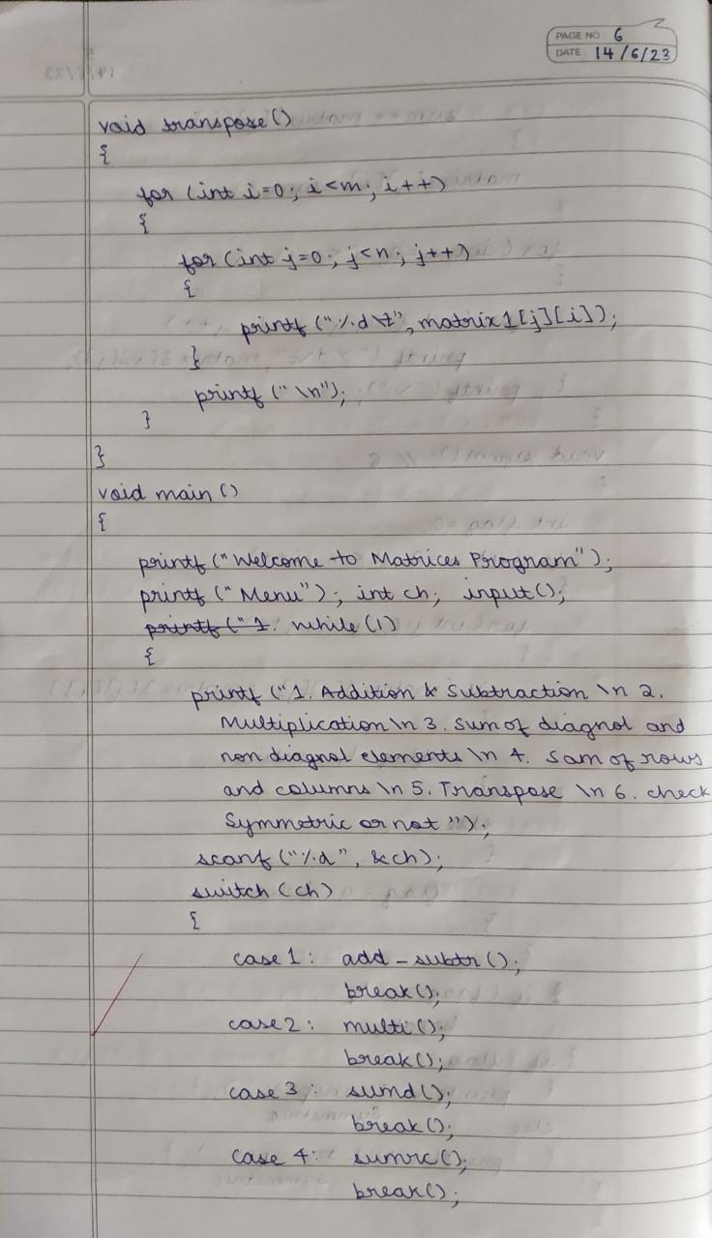

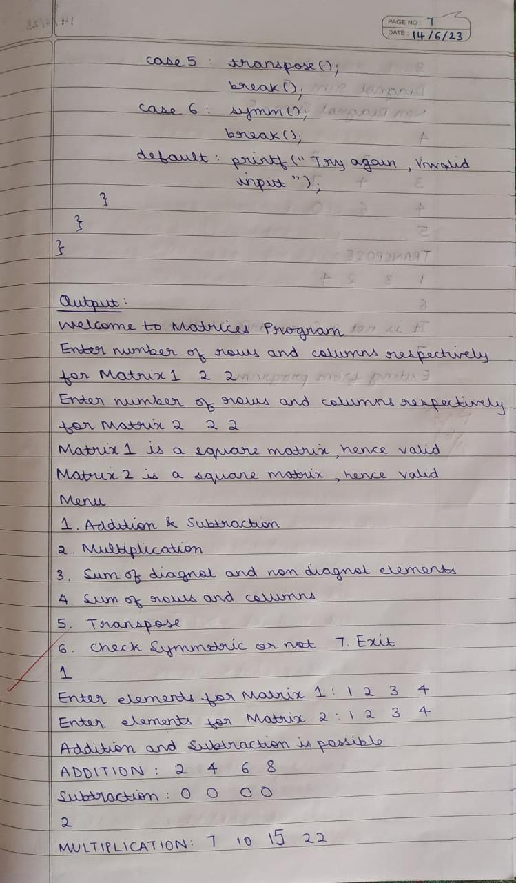

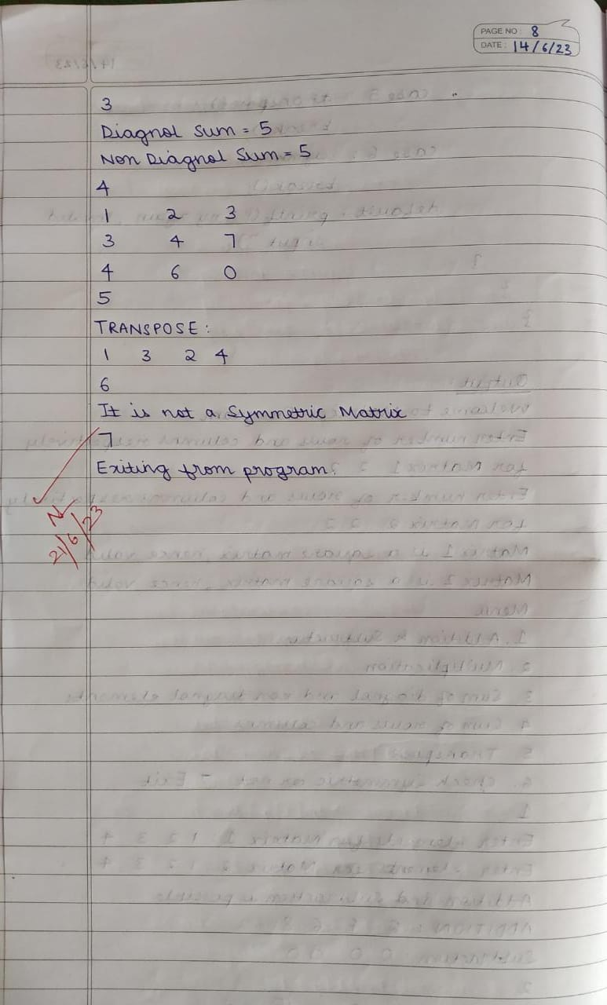

**OUTPUT:**

